**UNIEATS**

**divplusplus**

**Use Case Diagram**

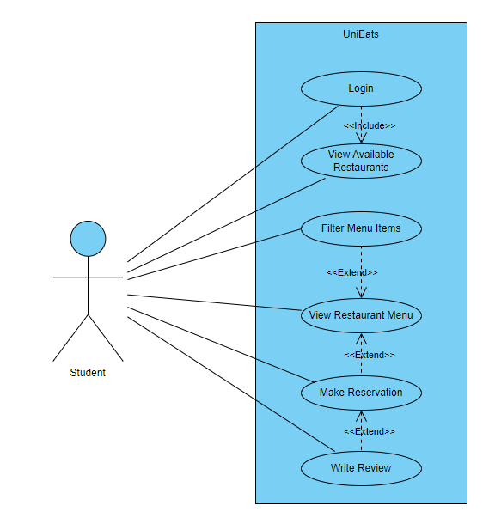

**All User Stories**

1. As a student, when I login to my profile, I will be able to view a list of all the restaurants available.
2. As a student, when I select my desired restaurant, I can see the menu.
3. As a student, I can filter the items on the menu, so that I am able to view the items that fit my dietary requirements.
4. As a student, I can make a reservation at my selected restaurant so that I can secure my spot at the restaurant.
5. As a student, I can write a review on the restaurant so that the restaurant can use my feedback.
6. As a student, I can view all previous reviews for a restaurant so that I can see if it's a good restaurant.
7. As a student, when I go onto my profile, I want to be able to view my credit balance.
8. As a student, when I enter a voucher code, I want my balance to be increased by the amount according to the voucher.
9. As a student, I can view my reservations so that I can confirm my reservations.
10. As a student, when I add items to the cart and checkout, I want to be notified when my order is ready so that I can collect it.
11. As a student, when I add items to the cart and checkout, I want to be able to view my previous orders so that I can see what I ordered.
12. As a student, I want to have secure access to my account so that no one else can log on to my profile and spend my credits.

**All User Acceptance Tests**

1. **View a list of all restaurants upon login**

* **Given**: I am a student with a valid account.
* **When**: I log into my profile on the UniEats platform.
* **Then**: I will see a list of all the restaurants available.

1. **View the menu of a selected restaurant**

* **Given**: I am logged into UniEats and viewing the list of available restaurants.
* **When**: I select a specific restaurant from the list.
* **Then**: I will be able to see the full menu for that restaurant.

1. **Filter menu items by dietary requirements**

* **Given**: I am viewing the menu of a selected restaurant.
* **When**: I apply a dietary filter (e.g., vegetarian, gluten-free, etc.).
* **Then**: The menu will update to only show items that meet my dietary requirements.

1. **Make a reservation at a restaurant**

* **Given**: I am viewing the menu of my selected restaurant.
* **When**: I fill in the reservation details (date, time, number of guests, special requests) and submit the form.
* **Then**: I will receive confirmation that my reservation has been made.

1. **Write a review for a restaurant**

* **Given**: I have visited a restaurant listed on UniEats.
* **When**: I navigate to the review section for the restaurant and submit my feedback.
* **Then**: My review will be successfully posted for the restaurant to view.

1. **View all previous reviews for a restaurant**

* **Given**: I am a student logged into the application and viewing a specific restaurant's page.
* **When**: I navigate to the review section of the restaurant's page.
* **Then**: I will see a list of all previous reviews for that restaurant.

1. **View credit balance on my profile**

* **Given**: I am a student logged into my account on the application.
* **When**: I navigate to my profile page.
* **Then**: I will be able to see my current credit balance.

1. **Increase balance by entering a voucher code**

* **Given**: I am a student logged into my account.
* **When**: I enter a valid voucher code on my profile or during checkout.
* **Then**: My balance will increase according to the amount specified by the voucher.

1. **View my reservations**

* **Given**: I am a student logged into my account.
* **When**: I navigate to the reservations section of my profile.
* **Then**: I will see a list of my past and upcoming reservations.

1. **Receive a notification when my order is ready**

* **Given**: I have added items to my cart, completed the checkout process, and my order is being prepared.
* **When**: My order is ready for collection.
* **Then**: I will receive a notification informing me that my order is ready.

1. **View previous orders**

* **Given**: I am a student logged into my account and have placed orders in the past.
* **When**: I navigate to the order history section of my profile.
* **Then**: I will see a list of my previous orders with details of what I ordered.

1. **Secure log in**

* **Given**: I am a student logged into my account and have placed orders in the past.
* **When**: I navigate to the order history section of my profile.
* **Then**: I will see a list of my previous orders with details of what I ordered.